Class I- GK- 13th August 2019; Tuesday
1. Which among the following IS NOT used in summers? ____________
i. Blanket ii Cooler iii. Air Conditioner iv. Cotton Clothes
2. Which IS THE TINIEST among these? __________________
i. Elephant ii Deer iii. Rat iv. Horse
3. Which among the following DO NOT bite? ____________
i. Mosquito ii Bee iii. Ant iv. Butterfly. .
4. Which among the following IS NOT an indoor game? ___________
i. Chess ii Cricket iii. Ludo iv. Playing Cards.
5. Which among these IS NOT related to our nation- India? ___________
i. Reindeer ii Lotus iii. Peacock iv. Tiger.
6. Which among the following is salty? ______________
i. Rain water ii River water
iii. Sea Water iv. (Bottled) Mineral Water
**************************************************

Class II- GK- 13th August 2019; Tuesday
1. Shri Ramnath Kovind is the _________________ of India.”
2. Who is the current Home Minister of India?
i. Mr. Amit Shah ii. Mr. Rajnath Singh
iii. Mr. Narendra Modi
3. What are the things not found in the bathroom?
i. pillow ii towel iii. soap iv. shower
4. Find the odd one out:
i. Bracelet ii Watch iii. Ring iv. Friendship- Band
5. Which among the following is a common noun?
i. Water ii. Diamond iii. Mercury iv Jet Airways
6. Give the opposites of:
i. Warm? __________
ii. North _______
**********************************************

Class III- GK- 13th August 2019; Tuesday
1. Who among the following is not a cricketer?
i. Mahendra Singh Dhoni ii. Virat Kohli
iii. Mahesh Bhupati iv. Sachin Tendulkar
2. DD is a national TV Channel. What is its full form?
i. Doordarshan ii. Daily Dose iii. Daily Drama iv. Divyadarshan
3. Which among the following can be used even if there is no electric current?
i. television ii. washing machine iii. calculator iv. mixer and grinder
4. Which among the following years was a leap year?:
i. 2009 ii. 2010 iii. 2011 iv. 2012
5. Which among the following is in the southern state of India?
i. Meenakshi Temple ii. Vaishnavo Devi Temple
iii. Somnath Temple iv. Konark Temple
6. Which among the following does not grow every now and then?
i. nails ii. hair iii. height iv. Teeth
**********************************************************

Class IV- GK- 13th August 2019; Tuesday
1. The longest river of the world is _________________?
i. Amazon- South America ii. Yangtze- Asia
iii. Zaire- Africa iv. Nile- Africa
2. Which among the following is the largest island of the World?
i. Sri Lanka ii. Sumatra
iii. Greenland iv. Great Britain
3. Which among the following is not associated with Tennis?
i. Wimbledon ii. FIFA World Cup
iii. French Open iv. Australian Open
4. Which Indian Political Party and its Leader are not correctly matched?
i. INC- Rahul Gandhi ii. TMC- Mamata Banerjee
iii. DMK -MK Stalin iv. SP- Mayawati
5. Which among the following companies does not manufacture cars?
i. Hyundai ii. Maruti iii. TVS iv. Volkswagen
6. Which among the following is not a gemstone?
i. Red Ruby ii. Blue Sapphire
iii. Green Emerald iv. White Ivory
*********************************************************
Class V- GK- 13th August 2019; Tuesday
1. Strike out the wrong pairs?
i. Assam - Dispur ii. Andhra Pradesh - Amaravati
iii. Arunachal Pradesh- Itanagar iv. Mizoram- Kavaratti
2. Which among the following is not a Capital City?
i. Bhilai ii. Bhubhaneswar iii. Kohima iv. Chandigarh
3. The highly endangered red panda is found in which of the following Indian State??
i. Arunachal Pradesh ii. Sikkim iii. Meghalaya iv. Manipur
4. Which among the following is not a Southern State Capital?
i. Hyderabad ii. Bengaluru iii. Kolkata iv. Trivandrum
5. Which among the following is not a Union Territory of India?
i. Puducherry ii. Daman and Diu iii. Lakshadweep iv. Goa
6. Who among the following is not an industrialist?
i. Mukesh Ambani ii. Ratan Tata
iii. Mukesh Khanna iv. Kumarmangalam Birla
****************************************************

Class VI- GK- 13th August 2019; Tuesday
1. Which country hosted the FIFA World Cup 2018?
i. Russia [ ] ii. Brazil [ ]
iii. France [ ] iv. Germany [ ]
2. Which among the following is not a male?
i. peacock [ ] ii. pea-hen [ ]
iii. Tom Cat [ ] iv. Gander [ ]
3. Who is the Chief of Army Staff of India?
i. General Dalbir Singh [ ] ii. General Bikram Singh [ ]
iii. General Vijay Kumar Singh [ ] iv. General Bipin Rawat [ ]
4. Where do children go to study after they pass out Class XII from school?
i. University [ ] ii. College [ ]
iii. Technical Institutes [ ] iv. i), ii) and iii) [ ]
5. What is the full form of FIFA in FIFA World Cup?
__________________________________________________________
6. Which among the following is not in Europe?
i. DRC [ ] ii. Italy [ ]
iii. France [ ] iv. Germany [ ]
*********************************************************

Class VII- GK- 13th August 2019; Tuesday
1. Expand the abbreviation IIM: _____________________________________________
2. What kind of mammals are kangaroos, opossums and
wallabies? ______________
3. Expand the abbreviation GATE: _____________________________
4. The festival in Tamil Nadu; wherein people run with the bulls, wrestle with it to hold them by the horns and take charge of the animals is a part of ________________ festival and is known as ___________________
5. Expand the abbreviation UPSC: __________________________________________
6. Kerala’s famous boat race is a spectacular event held annually during the harvest festival named as __________________________________
***************************************************

Class VIII- GK- 13th August 2019; Tuesday
1. i. Expand the abbreviation MBBS: _______________________
ii. Expand the abbreviation GATE: ________________________
2. Which among the following is INCORRECT?
i.Hirakud Dam- Mahanadi [ ] ii. Sardar Sarovar Dam- Narmada [ ]
iii. Mettur Dam- Kaveri [ ] iv. Gandhi Sagar Dam- Ganges [ ]
3. i. Expand the abbreviation IAS: ___________________________
ii. Expand the abbreviation IPCC: _________________________
4. Who among the following WAS an Indian grammarian?
i. Patanjali [ ] ii. Bharat Muni [ ]
iii. Chanakya [ ] iv. Panini [ ]
5. i. Expand the abbreviation NCC: __________________________
ii. Expand the abbreviation CISF: ________________________
6. Which among the following IS NOT a neighbouring state of Chhattisgarh?
i. Odisha [ ] ii. Arunachal Pradesh [ ]
iii. Jharkhand [ ] iv. Madhya Pradesh [ ]
****************************************************

Class IX- GK- 13th August 2019; Tuesday
1. Which among the following is the largest port of India?
a. Mumbai [ ] b. Paradip [ ]
c. Kandla [ ] d. Tuticorin [ ]
2. Which among the following is the Highest Civilian Award?
a. Param Veer Chakra [ ] b. Padmabhushan [ ]
c. Bharat Ratna [ ] d. Padmashree [ ]
3. When is International Yoga Day celebrated? ________________________________________
4. Which among the following is not a classical dance form of India?
a. Mohiniattam [ ] b. Kathakali [ ]
c. Lawni- Maharashtra [ ] d Kuchipudi [ ]
5. Give the full form of UNO _________________________________
16. Which among the following pairs are incorrect with respect to the timeline?
a. Mahatma Gandhi : 02-10- 1879 [ ]
b. Jawaharlal Nehru : 14-11-1889 [ ]
c. Chandrasekhar Azad : 23-07-1906 [ ]
d. Bhagat Singh : 28-09-1907 [ ]
******************************************************

Class X- GK- 13th August 2019; Tuesday
1. Identify the following personalities and name them:
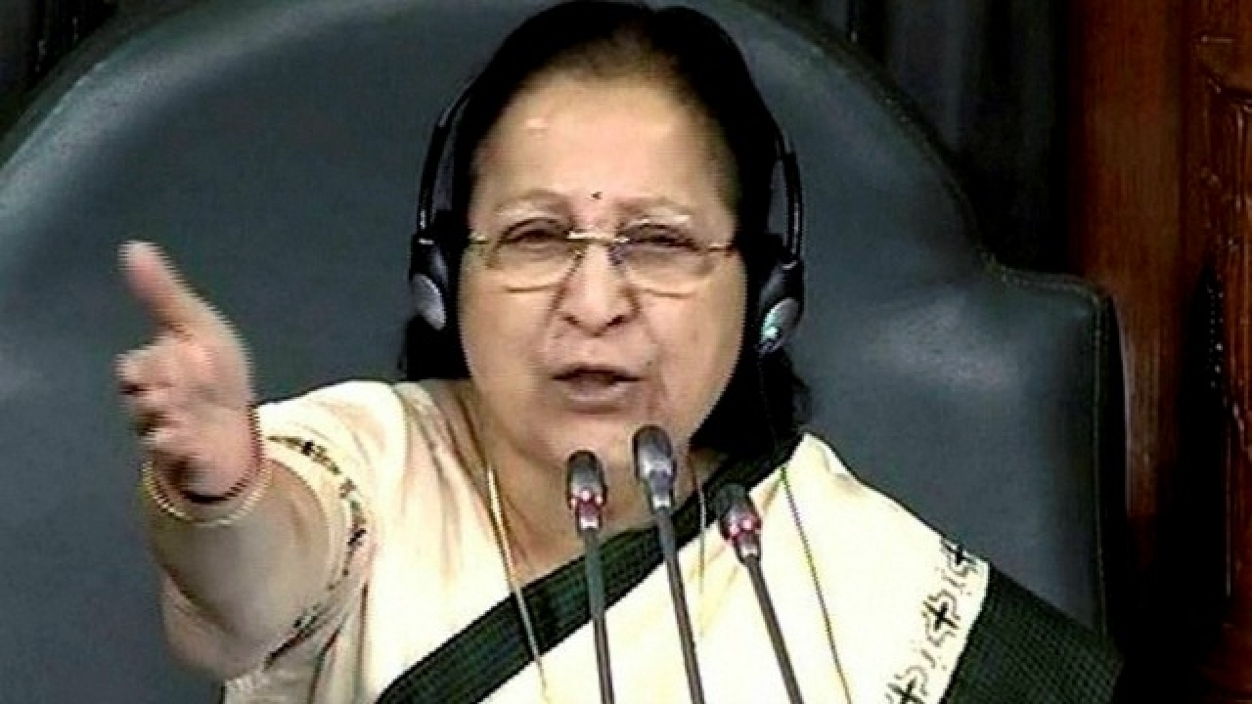
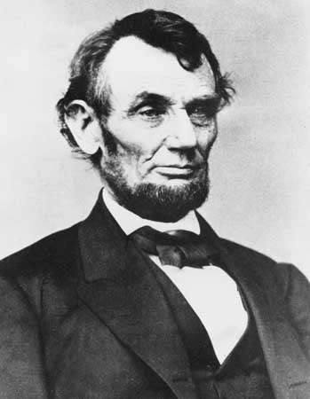

- ________________________ b. _____________________________
2. In which country were 12 boys along with their football coach trapped in a cave for 9 days and were finally rescued on 13th July 2018?
a. Thailand [ ] b. Malaysia [ ] c. Singapore [ ] d. Japan [ ]
3. When is International Yoga Day celebrated? ________________________________________
4. Which among the following is not a folk dance form of India?
a. Bihu- Assam [ ] b. Kathakali- Kerala [ ]
c. Lawni- Maharashtra [ ] d Kalbeliya- Gujarat[ ]
5. Give the full form of CISF? _______________________________________________________
6. Which among the following pairs are incorrect with respect to the timeline?
a. Mahatma Gandhi : 02-10- 1879 [ ]
b. Jawaharlal Nehru : 14-11-1889 [ ]
c. Chandrasekhar Azad : 23-07-1906 [ ]
d. Bhagat Singh : 28-09-1907 [ ]
*****************************************************************

Class XI- GK- 13th August 2019; Tuesday
1. Which country party won the majority in the Parliamentary Elections 2019?
a. BJP [ ] b. YSR Congress [ ]
c. TMC [ ] d. INC [ ]
2. What is the full form of FIFA? ____________________________
3. Here are A FEW CLUES on a personality who has contributed a lot to the society. Identify him.
a. He was born on 11th January 1954 in Vidisha, Madhya Pradesh.
b. An electrical engineer and an Indian Child Rights Activist founder of Bachpan Bachao Andolan
c. He is the Nobel Peace Prize recipient and has also been awarded the Bharat Ratna
d. A member of the UNESCO, he has efficiently carried forward the movement of Education For All
Who is he? ________________________________________________________

4. Which State of India is known as the Rice Bowl of India? _______________

5. Which colour among the following is not in the rainbow?
a. Silver & Golden [ ] b. Red Blue [ ]
c. Green- Yellow [ ] d. Violet- Indigo [ ]
6. Which among the following is the State bird of Chhattisgarh?
a. Pigeon [ ] b. Koel [ ]
c. Common hill Myna [ ] d. Baya-weaver bird [ ]
**********************************************************
Class XII- GK- 13th August 2019; Tuesday
1. Who designed the city of New Delhi? ______________________
2. Which State of India is known as the Land of Lamps? _______
3. Which among the following timelines is incorrect?
a. Mahatma Gandhi : 02-10- 1879 [ ]
b. Jawaharlal Nehru : 14-11-1889 [ ]
c. Chandrasekhar Azad : 23-07-1906 [ ]
d. Bhagat Singh : 28-09-1907 [ ]
4. Which among the following Environment Event launch date is mismatched?
a. Earth Day- 22nd April 1970 [ ]
b. World Environment Day- 5th June 1972 [ ]
c. Earth Hour – 23rd March 2007 [ ]
d. World Habitat Day- 10th October 1976 [ ]
5. The Biggest Monolith Statue in India is that of
a. Lord Hanuman in Aizawl [ ]
b. Gomateshwar in Shravanabelagola [ ]
c. Lord Jagannath in Puri [ ]
d. Buddha at Nalanda [ ]
6. Which among the following is the longest Railway route in India?
a. Chennai to Jammu Tawi [ ] b. Trivandrum to Varanasi [ ]
c. Dibrugarh to Kanyakumari [ ] d. Howrah to Ahmedabad [ ]
****************************************************************

